**BIA1B Business and Information Systems Architecture**

**MGMT-6134 Capstone Project**

**Connecting xyz: Modernizing Web Presence and Marketing Integration**

**Milestone 2**



**Group 1: BIA Falcon Synergy**

|  |  |
| --- | --- |
| *Section 32* | |
| Jim Raynor 11111111 |  |
| Sarah Kerrigan 11111111 |  |
| Anuj 11111111 (LIAISON) |  |
|  |  |
| *Section 31* | |
| Amit Patel 11111111 | |

**Table of Contents**

1. Milestone Summary 4

2. Web Search 4

2.1. Website Development Technologies and Frameworks 4

2.2. Security Considerations 7

2.3. Maintenance and Version Management 9

2.4. Website Design Principles 10

2.5. SEO and Analytics 13

2.6. Integration with HubSpot 14

2.7. Project Management 15

3. Use Case Diagram 17

3.1. Guest Use Cases 18

3.2. Admin Use Case 20

3.3. Admin and Marketing Staff Use Cases 22

4. Sequence Diagram 26

5. Draft of System Architecture 33

6. Draft of Entity-Relationship Diagram 34

7. Data Dictionary 35

8. UI/UX Prototypes and Demo 38

8.1. High-Fidelity wireframe of the Landing Page (Initial version) 38

8.2. High-Fidelity wireframe of the Landing Page (Second version) 39

8.3. Mid-Fidelity wireframes for Admin Portal Login Page and Admin Panel 40

8.4. Low-Fidelity wireframes for all the pages 41

9. References 43

10. Appendix 46

**Table of Figures**

Figure 1: Use Case Diagram 17

Figure 2: Sequence Diagram for Browse Content 26

Figure 3: Sequence Diagram for Submit Contact Form 27

Figure 4: Sequence Diagram for Create Support Ticket 28

Figure 5: Sequence Diagram for Modify Users 29

Figure 6: Sequence Diagram for Post Content 30

Figure 7: Sequence Diagram for Website Login 32

Figure 8: Sequence Diagram for Website Logout 32

Figure 9: System Architecture 33

Figure 10: Entity-Relationship Diagram 34

Figure 11: High-Fidelity Wireframe of Landing Page – Initial Version 38

Figure 12: High-Fidelity Wireframe of Landing Page – Second Version 39

Figure 13: Mid-fidelity wireframes for Admin Portal Login Page and Admin Panel 40

Figure 14: Low-fidelity wireframe for the landing page 41

Figure 15: Low-fidelity wireframes for the other pages 1 41

Figure 16: Low-fidelity wireframes for the other pages 2 42

Figure 17: Low-fidelity wireframes for the admin portal 42

Figure 18: Gantt Chart Weekly View Milestone 2 46

Figure 19: Milestone 2 Details 47

**Table of Tables**

Table 1: Milestone summary and status 4

Table 2: Use Case Description - Browse Content 18

Table 3: Use Case Description - Submit Contact Form 19

Table 4: Use Case Description - Create Support Ticket 20

Table 5: Use Case Description - Manage Users 21

Table 6: Use Case Description - Manage Content 23

Table 7: Use Case Description - Login to Website 24

Table 8: Use Case Description - Logout of Website 25

Table 9: Data dictionary - User table 35

Table 10: Data dictionary - News_Events table 35

Table 11: Data dictionary - Case_Study table 36

Table 12: Data dictionary - Testimonial table 36

Table 13: Data dictionary - Careers table 37

Table 14: Data dictionary - Support_Ticket table 37

## Milestone Summary

During this milestone, research work began which resulted in decision-making about the technologies, methodologies, software, architecture (system and database), and data dictionary to be used. Prototype of the website started, and detailed requirement gathering was performed using UML diagrams.

|  |  |  |  |  |
| --- | --- | --- | --- | --- |
| **Event** | **Title** | **Start** | **Due** | **Status** |
| Milestone 1 | Inception | May-06 | May-31 | Completed |
| Milestone 2 | Analysis | June-01 | June-21 | Completed |
| Milestone 3 | Design | June-22 | July-19 | Not Started |
| Milestone 4 | Development | July-20 | Aug.-09 | Not Started |
| Final | Evaluation | Aug.-10 | Aug.-16 | Not Started |

Table : Milestone summary and status

At this stage of the capstone project, all required steps for Milestone 2 completion have been performed and documented, which are:

* Web Search
* Detailed requirements documentation (Use Case Diagram, Use Case Descriptions, Sequence Diagrams)
* Draft of:
  + System Architecture
  + Entity-Relationship Diagram (Physical Data Model)
  + Data Dictionary
  + UI/UX Prototypes

## Web Search

Following an extensive web search, our team has identified a wide range of technologies and methodologies to build the new XYZ website. Our goal is to ensure the site is not only stable and efficient but also user-friendly and cost-effective. The selected approaches would enhance the website's performance, security, and overall user experience.

### Hardware Development Technologies and Frameworks

Our project relies on the ESP32 microcontroller and the MAX30102 pulse oximeter/heart rate sensor. Together, they form the core hardware layer for real-time physiological data acquisition, processing, and communication. The hardware development is supported by microcontroller programming frameworks, peripheral libraries, and testing tools to ensure accurate data collection and efficient device operation.

#### **Microcontroller Frameworks**

* **Arduino Core for ESP32**: The Arduino Core provides a simplified development environment for programming the ESP32. It offers high-level APIs for GPIO, I²C, SPI, WiFi, and sensor integration. We chose Arduino Core because it speeds up development through pre-built libraries, including support for the MAX30102 sensor, and integrates easily with the Arduino IDE or PlatformIO. In our project, Arduino Core is used for rapid prototyping, handling sensor data acquisition, and transmitting results via WiFi or Bluetooth.
* **ESP-IDF (Espressif IoT Development Framework)**: ESP-IDF is the official framework from Espressif, offering low-level hardware control, multitasking via FreeRTOS, and optimized networking stacks. While it is more complex than Arduino Core, ESP-IDF provides greater flexibility and fine-grained resource management. In the current phase, we will not rely on ESP-IDF to avoid overcomplicating development. However, if additional time is available in later project stages, we will consider migrating selected modules (e.g., real-time multitasking or advanced power optimization) to ESP-IDF to enhance system robustness.

#### **Sensor Integration Technologies**

* **I²C Communication Protocol**: The MAX30102 communicates with the ESP32 through the I²C protocol. We chose I²C because it is efficient, requires only two data lines (SDA and SCL), and supports reliable communication between microcontrollers and low-power sensors. In our project, I²C is used to transmit raw infrared and red-light readings from the MAX30102 to the ESP32 for further processing.
* **MAX30102 Sensor Library**: Open-source MAX30102 libraries are used to simplify the interaction with the sensor. These libraries provide functions for initializing the sensor, reading raw photoplethysmography (PPG) signals, and calculating heart rate and SpO₂ levels. Using these libraries allows us to focus on algorithm implementation instead of low-level sensor configuration.

#### **Development Tools**

* **Arduino IDE / PlatformIO:** Arduino IDE is used for quick development and deployment, while PlatformIO (inside Visual Studio Code) is used for more advanced debugging and dependency management. Both tools allow uploading code to the ESP32, monitoring serial output, and testing sensor data in real time.
* **Serial Monitor:** For debugging I²C signals and verifying communication between ESP32 and MAX30102, the built-in Arduino Serial Monitor is used. This helps ensure the reliability of data transfer and validates sensor initialization.

#### **Wireless Communication Frameworks**

* **WiFi (IEEE 802.11 b/g/n):** WiFi is integrated into the ESP32 and is used to transmit health data to a remote server or web application. We selected WiFi because it provides high data throughput and supports direct integration with cloud platforms for real-time monitoring.
* **Serial Monitor:** For debugging I²C signals and verifying communication between ESP32 and MAX30102, the built-in Arduino Serial Monitor is used. This helps ensure the reliability of data transfer and validates sensor initialization.

#### **Algorithmic Processing**

* **Signal Processing Libraries (C/C++):** The raw data from the MAX30102 requires filtering (e.g., moving average or FIR filters) and peak detection algorithms to calculate accurate heart rate and SpO₂. C/C++ libraries for digital signal processing are integrated within the ESP32 codebase to ensure real-time performance.

### Security Considerations

#### **Secure Data Management**

* **Data Encryption:** Implementing data encryption and strict access control measures is crucial for safeguarding data integrity and privacy. Sensitive information must be protected through comprehensive error handling protocols, ensuring error messages do not expose vulnerabilities. We will utilize PHP libraries like OpenSSL for encrypting sensitive data (php, n.d.) and store passwords using PHP’s *password_hash()* function with strong hashing algorithm (php, n.d.).
* **Secure Session Management:** Utilizing secure session management practices is essential for maintaining security. This includes using secure cookies, setting appropriate session timeouts, and regenerating session IDs after each login to mitigate potential session hijacking risks. We can set cookies with *HttpOnly* and Secure flags to prevent XSS and man-in-the-middle attacks (php, n.d.). We’ll also implement *ini_set()* to set session timeouts and regenerate session IDs periodically (php, n.d.).
* **Regular Backups and Integrity Checks**: Conducting regular backups and ensuring their secure storage is critical. Backups should be encrypted to prevent unauthorized access, and regular validation is necessary to confirm they can be restored successfully in case of data loss or corruption (Quilty, 2024). This process can be automated using tools like *mysqldump* and *cron* jobs for regular backup schedules. However, these tasks will be managed by the hosting provider to ensure consistent execution and verification of backup integrity.

#### **User Access Controls**

* **Authentication and Authorization:** Securing the admin dashboard and other critical access points with strong authentication mechanisms is imperative to ensure that only authorized personnel can access and modify sensitive content. For the admin dashboard and phpMyAdmin, we will enforce strong password policy and explore implementing two-factor authentication via external applications such as Google Authenticator (phpMyAdmin, n.d.).
* **User Management and Access Levels:** We have two main user roles: *Marketing Staff* and *Admin*. The Marketing Staff can manage dynamic content in the News & Events section, while Admins have full control over all content, including user management. The user table in the database records these roles under the *user_type* column to enforce access restrictions accordingly. We can implement role-based access control (RBAC) by defining roles and permissions in the MySQL database by restricting database access using MySQL’s *GRANT* statement to specify user privileges (MySQL, n.d.).
* **Controlled Access to Management Tools:** Restricting access to critical management tools such as phpMyAdmin to trusted IP addresses helps mitigate the risk of unauthorized usage. Access to these tools should always be over HTTPS to ensure encrypted communication between the client and server. We will limit access to phpMyAdmin to trusted IP addresses using *.htaccess* and enable HTTPS and SSL for secure connections (phpMyAdmin, n.d.).

#### **System Updates and Scalability**

* **Load Balancing and Traffic Management:** Utilizing load balancers and other traffic management techniques helps in evenly distributing system load and prevents overloads that could lead to Denial-of-Service (DoS) attacks. This is crucial for managing high traffic volumes and ensuring the system can scale efficiently with growing user demands. It can be set up load balancing using Apache’s *mod_proxy_balancer* to distribute traffic evenly and prevent DoS attacks (Apache, n.d.).
* **Scalable Infrastructure Implementation:** Incorporating scalability techniques such as load balancing ensures that the system can handle increased user traffic and adapt to growing requirements seamlessly (Apache, n.d.). This helps maintain performance and reliability, even under high-demand scenarios.
* **Regular Software Updates:** Maintaining up-to-date software components is essential for reducing security vulnerabilities and ensuring optimal performance. Regular updates and maintenance are fundamental to keeping the system resilient against emerging threats.

The three practices described should be implemented in the production environment to ensure availability, reliability, and scalability. In our project, the production environment will be managed by a third party, who will be responsible for implementing these practices.

### Maintenance and Version Control

To ensure stability, reliability, and long-term usability of the project, we will implement clear maintenance procedures and a structured version control strategy.

#### **Maintenance**

* **Bug Fixes and Updates:** Utilizing load balancers and other traffic management techniques helps in evenly distributing system load and prevents overloads that could lead to Denial-of-Service (DoS) attacks. This is crucial for managing high traffic volumes and ensuring the system can scale efficiently with growing user demands. It can be set up load balancing using Apache’s *mod_proxy_balancer* to distribute traffic evenly and prevent DoS attacks (Apache, n.d.).
* **Dependency Management:** Incorporating scalability techniques such as load balancing ensures that the system can handle increased user traffic and adapt to growing requirements seamlessly (Apache, n.d.). This helps maintain performance and reliability, even under high-demand scenarios.
* **Hardware Maintenance:** Utilizing load balancers and other traffic management techniques helps in evenly distributing system load and prevents overloads that could lead to Denial-of-Service (DoS) attacks. This is crucial for managing high traffic volumes and ensuring the system can scale efficiently with growing user demands. It can be set up load balancing using Apache’s *mod_proxy_balancer* to distribute traffic evenly and prevent DoS attacks (Apache, n.d.).
* **Documentation Updates:** Utilizing load balancers and other traffic management techniques helps in evenly distributing system load and prevents overloads that could lead to Denial-of-Service (DoS) attacks. This is crucial for managing high traffic volumes and ensuring the system can scale efficiently with growing user demands. It can be set up load balancing using Apache’s *mod_proxy_balancer* to distribute traffic evenly and prevent DoS attacks (Apache, n.d.).

#### **Version Control**

* **Bug Fixes and Updates:** Utilizing load balancers and other traffic management techniques helps in evenly distributing system load and prevents overloads that could lead to Denial-of-Service (DoS) attacks. This is crucial for managing high traffic volumes and ensuring the system can scale efficiently with growing user demands. It can be set up load balancing using Apache’s *mod_proxy_balancer* to distribute traffic evenly and prevent DoS attacks (Apache, n.d.).
* **Dependency Management:** Incorporating scalability techniques such as load balancing ensures that the system can handle increased user traffic and adapt to growing requirements seamlessly (Apache, n.d.). This helps maintain performance and reliability, even under high-demand scenarios.
* **Hardware Maintenance:** Utilizing load balancers and other traffic management techniques helps in evenly distributing system load and prevents overloads that could lead to Denial-of-Service (DoS) attacks. This is crucial for managing high traffic volumes and ensuring the system can scale efficiently with growing user demands. It can be set up load balancing using Apache’s *mod_proxy_balancer* to distribute traffic evenly and prevent DoS attacks (Apache, n.d.).
* **Documentation Updates:** Utilizing load balancers and other traffic management techniques helps in evenly distributing system load and prevents overloads that could lead to Denial-of-Service (DoS) attacks. This is crucial for managing high traffic volumes and ensuring the system can scale efficiently with growing user demands. It can be set up load balancing using Apache’s *mod_proxy_balancer* to distribute traffic evenly and prevent DoS attacks (Apache, n.d.).

### Website Design Principles

#### **Responsive Design**

Responsive design is a crucial feature that ensures our website is mobile-friendly and seamlessly adapts to various screen sizes and devices. Here are the key features we plan to implement for an optimal viewing experience:

* **Flow:** We will adopt percentage-based widths rather than fixed units, enabling elements to resize proportionally as the screen size changes.
* **Breakpoints:** We will set additional breakpoints tailored to our content needs, allowing us to optimize user experience across a variety of devices. For instance, we can switch from a multi-column layout to a single-column layout on smaller screens.
* **Max and Min Values:** These values will be used to prevent content from becoming too wide or shrinking excessively. They will also control the vertical stretching of elements.
* **Nested Objects**: These elements will allow each content section (e.g., header, main content, sidebar, footer) to be contained within its own div, enabling us to style and manipulate each section independently based on the viewport size.
* **Fonts**: We prefer System Fonts for primary content over Web Fonts because they load faster. These fonts are pre-installed on user devices, ensuring a consistent experience. However, we will explore open-source fonts to enhance the look and feel of our website.
* **Customization:** We will explore free and open-source Bootstrap skins to customize the default Bootstrap components and layouts, aligning them with our design requirements. (FROONT, 2014)

#### **User Experience (UX)**

User experience (UX) considers the overall interaction of users with our site, focusing on its simplicity, effectiveness, and satisfaction. Here are the best practices we will follow:

* **Navigation**: A clear, accessible navigation bar will be implemented at the top of each page with descriptive labels for menu items that accurately reflect their content or functionality.
* **Clear Menus**: Menus will be designed with recognizable labels organized logically. Dropdown menus will be used for subcategories.
* **Header and Footer:** Each page will have a consistent header and footer. The header will contain the main navigation, while the footer will include links to critical sections, such as contact information and social media platforms.
* **Breadcrumbs:** A breadcrumb trail will be displayed at the top of content pages, typically above the main content area. Each breadcrumb link will be clickable, allowing users to easily return to higher-level pages
* **Accessibility**: Our aim is to create a website that is usable by as many people as possible. We will use the following features to make this possible:
  + **Alt Text for Images**: Concise yet descriptive alt text will be written for all images, explaining their content or purpose to keep users informed of the displayed content.
  + **Image Contrast**: All images will be optimized with high contrast, ensuring enhanced visibility and readability, making them accessible for users with visual impairments.
* **Usability**: Our focus is on making the website intuitive, easy to understand, and operate, ensuring users can achieve their goals efficiently. We will use the following features to ensure usability:
  + **Consistent Layout**: Consistent templates will be used for similar types of pages to maintain uniformity. A consistent spacing system (margins, padding) will be employed throughout the website for alignment and layout consistency.
  + **Loading Indicators**: Loading indicators will be incorporated to provide visual feedback during loading times, reassuring users that their action is being processed and preventing frustration. (Example: a progress bar will show during content loading or data fetching processes.)
  + **Repetition**: We will ensure cohesion by maintaining consistency in elements like buttons, spacing, headers, footers, and color schemes throughout the website. This includes applying consistent styles for buttons, links, etc., keeping headers, footers, and other repeated elements uniform across pages, and using a consistent color scheme to reinforce branding. (Lucidspark, n.d.)

#### **UI/UX Tools**

UI/UX tools are vital in our design process. They are software applications that facilitate the design and prototyping of user interfaces and experiences, streamlining the creation, iteration, and collaboration process.

* **Adobe XD**: Adobe XD supports the creation of scalable vector graphics, which assists in designing interfaces that are visually appealing across all screen sizes. This tool is excellent for creating high-fidelity prototypes and designing user flows with interactive elements. (Adobe, n.d.) We utilized this popular tool to design our initial high-fidelity wireframe for the Landing page.
* **Figma**: Figma is entirely cloud-based, allowing for real-time collaboration. It enables multiple designers to work simultaneously on the same file, making it effortless for our team members to share insights and implement designs together. Figma is particularly suited for teams that work remotely or require frequent collaboration, as it supports real-time updates and feedback. (Figma, n.d.) We utilized this tool for the updated version of the Landing Page to present to the client.

#### **Competitor Analysis**

Our goal in conducting a competitor analysis is to critically evaluate our website in comparison to our competitors. This allows us to identify unique features that set us apart and areas where we could potentially improve.

* **Identifying Competitors**:
  + We selected businesses or websites within our industry that cater to a similar demographic or offer comparable products/services. For example, we thoroughly analyzed the website of one of XYZ’s competitors, Enginuity Inc (Enginuity Inc, 2024). The client chose this website based on factors such as market presence, similarity in product/service offerings, and target audience.
  + We also considered the overall design used by other companies in the same industry, such as British Engines (Britishengines, 2024), Sci Engineering (Sci Engineering, 2019), and Baker Hughes (Baker Hughes, 2024), among others.
* **Feature Comparison**
  + **Design**: We assessed the aesthetic quality, branding consistency, and overall visual engagement of our competitors' websites. We also evaluated whether their layout effectively and intuitively presented information.
  + **Functionality**: We made a list of key features our competitors offer, such as lead capture forms, e-commerce capabilities, customer portals, and unique interactive elements.
* **Distinguishing Factors**:
  + **Unique Design Elements**: We aimed to identify design aspects that make our website stand out, such as distinctive visual styles, innovative technology usage, or custom graphics.
  + **User Experience**: We highlighted features that enhance user engagement, such as dynamic content, interactive elements, or personalized experiences.
  + **Technology**: We meticulously examined and noted any advanced technologies or frameworks our competitors might lack.

We are leveraging various UX/UI tools to create an engaging design that stands out from our client’s competitors. Our goal is to create an online presence that not only encapsulates XYZ’s brand identity but also provides an enhanced user experience that meets the needs and expectations of our audience.

### SEO and Analytics

To enhance the performance and visibility of the website, a strategic approach that integrates best practices in SEO, analytics, and site speed optimization is essential.

#### **SEO Best Practices**

* **On-Page SEO techniques**: On-page SEO involves optimizing individual web pages to rank higher in search engines. This includes optimizing content, meta tags, and URLs (Patel, n.d.). In this project, on-page SEO will be implemented by optimizing the HTML structure with relevant keywords, adding meta descriptions, and ensuring clean URL structures for all pages.
* **Mobile friendliness:** Mobile SEO ensures that a website is optimized for mobile devices, providing a seamless user experience across different screen sizes (Google, n.d.). Our project incorporates responsive design techniques using CSS and media queries to adapt the layout for various devices, ensuring optimal usability and accessibility.

#### **Analytics Tools**

* **HubSpot Analytics:** Analytics provides detailed insights into marketing performance, including website traffic, leads, and conversion tracking (HubSpot, n.d.). HubSpot Analytics will be utilized to monitor marketing efforts, assess campaign performance, and make data-driven decisions to optimize user engagement and conversion rates. We aim to use this feature of HubSpot since it is the CRM platform that our client is currently using. However, we need to verify that the subscription acquired by XYZ supports this functionality. If it does not, we recommend that XYZ conducts a cost-benefit analysis to decide whether we should implement this feature in our project.
* **Google Analytics:** Google Analytics is a robust tool that tracks and reports website traffic, providing insights into user behavior and site performance (Google, n.d.). In the new website, Google Analytics will be used to track key metrics such as user sessions, bounce rates, and conversion rates. We can use this tool from Google in case the client wants to evaluate a cost-free resource to perform their analytics.

#### **Site Speed Optimization**

Google PageSpeed Insights (PSI) analyzes web page performance and provides suggestions for speed improvement (Google, n.d.). It is a powerful tool that analyzes the performance of web pages and provides actionable insights to enhance site speed and user experience. For this project, this tool will be crucial in transitioning from the existing old website to a new, optimized version. We will use Google PageSpeed Insights to identify and resolve issues affecting the site speed, such as image compression, browser caching, and server response time.

PSI’s focus on Core Web Vitals ensures that the new website is not only fast but also provides a stable and interactive experience. This includes improvements in visual stability, interactivity, and loading performance, which are crucial for maintaining user engagement and satisfaction. The prioritization of these enhancements, based on PSI’s actionable insights, will help our new website outperform its predecessor by offering a more responsive and efficient user experience, ultimately leading to higher search engine rankings and better user retention.

### Integration with HubSpot

The primary technology selected for integrating the HubSpot platform into XYZ’s website involves using HubSpot’s embedded code functionalities. This includes embedding lead capture forms, handling form submissions, managing subscriptions, and tracking website analytics. (HubSpot, 2018)

#### **Benefits of HubSpot Integration**

* **Ease of Integration:** Using embedded codes provided by HubSpot allows seamless integration with the website without extensive backend modifications or the need for API development. It simplifies the process of adding HubSpot's functionalities directly into the website’s existing structure. (HubSpot, 2018)
* **Real-time Data Synchronization:** Embedded forms and scripts can make sure that data captured from the website is immediately sent to HubSpot. This real-time synchronization is crucial for timely follow-up on leads and accurate tracking of user interactions. (HubSpot, 2024)
* **Customization and Flexibility:** HubSpot’s embedded codes are highly customizable, allowing the forms and tracking functionalities to match the website’s design and functional requirements. This flexibility ensures a consistent user experience across the website. (HubSpot, 2018)
* **Comprehensive Analytics:** HubSpot’s embedded tracking code captures detailed visitor interactions, such as page views and clicks, which are then synced with HubSpot’s CRM. This comprehensive data collection is essential for informed decision-making and targeted marketing strategies. (HubSpot, n.d.)

#### **Lead Capture Forms**

* **Embedding Forms:** Customizable HubSpot CRM forms will be embedded directly into the XYZ website. This will be done by copying the form’s embedded code from HubSpot and pasting it into the website’s HTML where the form should appear. (HubSpot, 2024)
* **Form Customization:** The forms will be tailored to capture specific lead information relevant to XYZ’s needs. Fields can be added, removed, or modified within HubSpot, and the changes reflect instantly on the website. (HubSpot, 2024)

#### **Form Submission Handling**

* **Automatic Data Capture:** When a user submits a form, the data is automatically routed to HubSpot’s CRM system. This is achieved through the embedded form’s built-in functionality, which sends the submission data directly to HubSpot. (HubSpot, 2024)
* **Lead Routing:** HubSpot workflows can be set up to ensure that leads are categorized and assigned to appropriate team members for follow-up. (HubSpot, n.d.). Our website will assist XYZ in generating more traffic and increasing lead generation. However, to achieve the company’s goal of increasing sales, we recommend configuring workflows in HubSpot to assist with lead nurturing tasks after form submission, helping the enterprise manage the expected increase of leads.

#### **Website Analytics**

* **Tracking Code Integration:** HubSpot’s tracking code will be embedded into the website’s header. This code will monitor user interactions, such as page views and clicks, and will send this data to HubSpot. (HubSpot, 2018)
* **Data Utilization:** The analytics data collected will be used to generate reports within HubSpot, providing insights into user behavior and the effectiveness of marketing campaigns. (HubSpot, n.d.)

### Project Management

#### **Methodology**

Currently in the information technology industry, the most common project management methodologies are Waterfall, Agile, Scrum, Kanban, and Lean (Coursera, 2024). For our capstone project, we selected a hybrid methodology combining elements of Waterfall and Scrum.

* + **Waterfall Methodology**: Waterfall is well-suited for projects with well-defined requirements. However, it can be lengthy, with the final product delivered long after the initial specifications (Sommerville, 2016). To implement this methodology, we created a Work Breakdown Structure (WBS) and a Gantt chart at the beginning of the project, outlining all deliverables required. This structured approach allows us to plan effectively, ensuring we meet all objectives within the established milestones.
  + **Scrum Methodology:** This methodology offers a flexible and efficient framework that can adapt to changes and validate the project through frequent deliverables, thereby reducing risk of not meeting the customer expectations (Tilley, 2020). Given that website design allows for creativity and potential changes during development, we decided to incorporate Scrum. We reviewed the Scrum documentation (Sutherland, 2020) and implemented its core elements as follows:
    - **Sprints:** We conduct one-week sprints, delivering meaningful progress every week.
    - **Review, Planning, and Retrospective:** Every Monday, we hold a meeting to review the previous sprint's deliverables, discuss what went well and what didn't, and plan the upcoming sprint.
    - **Increment**: Each sprint delivers valuable elements to the project.
    - **Product Backlog and Sprint Backlog**: Using Jira software, we maintain a list of all deliverables for our capstone project, which represents our backlog. This is the merging point between the waterfall plan that we did and the product and sprint backlog from the agile methodology.
    - **Daily Scrum:** To balance workloads with other responsibilities, we submit reports twice a week in an Excel file, detailing recent progress, upcoming tasks, and any blockers. Our Scrum Master (Project Manager) reviews these reports to address issues.

#### **Project and issue management tools**

JIRA is well-suited for software development teams, allowing developers and IT professionals to manage their projects using Scrum or Kanban boards (Springer, 2023). We decided to use JIRA to keep track of tasks, make schedules, assign resources, manage project problems, bugs, and new feature requests. We registered all our deliverables in JIRA, assigning responsibilities along with start and finish dates. With JIRA's free tier allowing up to 10 users, we created accounts for each team member to share status updates and track progress.

#### **Online Meeting Tools**

Microsoft Teams is a well-known industry-standard tool for meetings and collaboration. We are using Microsoft Teams for online meetings, leveraging the license included in our Fanshawe College tuition fees, which offers unlimited meeting time.

#### **Documentation**

Documenting code, integrations, and processes are crucial for maintaining project continuity, team collaboration, and knowledge transfer. It helps in troubleshooting and mitigating risks associated with change management. Documentation will also ensure that the website that we are building in our capstone project, can be maintained in the future, by ourselves or XYZ’s team. We chose to use Microsoft Office Suite for file sharing via OneDrive and used MS Office suite to create several documents. We are using Draw.io and GitHub for diagram generation and code documentation respectively. These tools are well-regarded in the industry for documentation projects. Besides being well-known, GitHub allows for collaborative work with effective version control.

## Use Case Diagram

The Use Case Diagram provides a visual representation of the different actors that will interact with the new XYZ website and the various ways these interactions occur. It outlines the specific functionalities accessible to three actors:

* **Guest**: can submit contact forms, browse content, and create support tickets, reflecting a more general level of access suitable for external users.
* **Admin**: possesses higher-level access, can log in to the website, manage users, manage content, log out, and recover forgotten passwords, indicating a comprehensive set of administrative capabilities necessary for website maintenance and user management.
* **Marketing Staff**: this role is specifically aligned with content management related to marketing, allowing them to oversee and update website content.

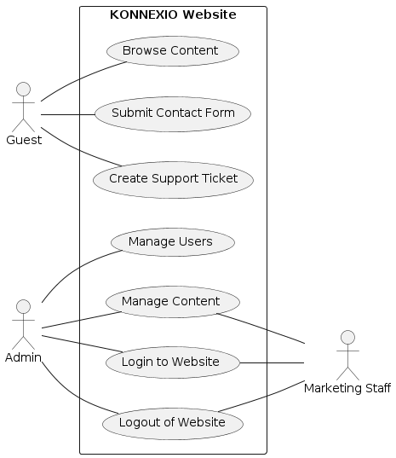

Figure : Use Case Diagram

The following will describe each of the use cases identified for this project.

### Guest Use Cases

|  |  |
| --- | --- |
| Use Case #1: Browse Content | |
| Name | Browse Content |
| Description | This use case involves browsing publicly available content on the website. It includes navigating through different sections, viewing content details, and searching for specific content. |
| Actor | Guest |
| Pre-Condition | The website is online and accessible. |
| Post-Condition | The guest user views the desired content. |
| Main Success Path | 1. The guest goes to the website URL. 2. The guest navigates to the content section via the main menu or homepage. 3. The guest browses through categories or sections to find the desired content. 4. The guest selects a piece of content to view. 5. The system displays the content details, including text, images, and other relevant information. 6. The guest may return to browsing for additional content as desired. |
| Alternate Path | * If the guest attempts to view content that is restricted or requires login, the system displays a message indicating that login is required to access the content. |
| Exception Path | * If the website is down or experiencing technical issues, the system displays an error message and advises the guest to try again later. * If the content is not available or has been removed, the system displays a "Content Not Found" message. |

Table : Use Case Description - Browse Content

|  |  |
| --- | --- |
| Use Case #2: Submit Contact Form | |
| Name | Submit Contact Form |
| Description | This use case involves a guest user submitting a contact form embedded on the website. The form is created using the HubSpot platform and is designed to capture user information for lead generation and follow-up. |
| Actor | Guest |
| Pre-Condition | * The guest has accessed the website URL. * The form is created and maintained by the business on the HubSpot platform and is properly embedded and functional on the website. |
| Post-Condition | * The guest's form submission is successfully captured by HubSpot, and the guest receives a confirmation message. The business receives the captured data for follow-up. |
| Main Success Path | 1. The guest navigates to the Contact page where the embedded HubSpot contact form is located. 2. The guest fills out the required fields such as name, contact information, and message. 3. The guest may optionally provide additional details in the message. 4. The guest clicks the Submit button to send the form. 5. HubSpot validates the form, ensuring all required fields are completed correctly and data is in the appropriate format. 6. Upon successful validation, HubSpot processes the submission and logs the details in its system. 7. The form triggers a confirmation message on the website, informing the guest that the submission was successful. 8. The guest receives a confirmation email from HubSpot acknowledging receipt of their message. |
| Alternate Path | * If the guest chooses not to submit the form, they can leave the page without submitting, and no data is retained. * If the guest needs to reset the form, they can clear all fields by using a Reset button or manually deleting the entered information. |
| Exception Path | **Missing or Invalid Data:**   * If required fields are not filled or contain incorrect data, HubSpot highlights the fields needing correction and displays an error message. The guest corrects these errors and resubmits the form.   **Technical Issues:**   * In the event of technical problems (e.g., server issues), HubSpot displays an error message advising the guest to try again later or to contact support through an alternative method.   **Spam Detection:**   * If HubSpot detects potential spam (e.g., due to content or multiple submissions), it prompts the guest with additional verification measures such as a CAPTCHA to ensure the submission's validity. |

Table : Use Case Description - Submit Contact Form

|  |  |
| --- | --- |
| Use Case No. 3: Create Support Ticket | |
| Name | Create Support Ticket |
| Description | This use case involves existing customers submitting a support ticket to request assistance with issues related to the product or service. The ticket submission is handled through a form on the website, allowing customers to detail their problem and receive support from the business. |
| Actor | Guest |
| Pre-Condition | * An existing customer (considered as guest on the website) has encountered an issue with the product or service and needs support. * The guest accesses the website where the support ticket form is available. |
| Post-Condition | * The support ticket is successfully submitted and logged in the system, and the guest receives a confirmation message. The business is notified and can begin the process to address the issue. |
| Main Success Path | 1. The guest navigates to the Contact section to create a support ticket. 2. The guest accesses the support ticket form. 3. The guest fills out the form, providing details such as their name, contact information, issue description, and any relevant information. 4. The guest selects the issue category, priority, or other information if applicable. 5. The guest submits the form by clicking the Submit button. 6. The system validates the form to ensure all required fields are completed and data is in the correct format. 7. Upon successful validation, the system routes the form to the Support Team mailbox. 8. The system displays a confirmation message with further instructions or expectations regarding follow-up from Support Team. |
| Alternate Path | * If the guest decides not to submit the support ticket, they can navigate away from the page without submitting. The system does not retain any information entered in the form. * If the guest wishes to clear the form, they can use a Reset button or manually clear the fields to start over. |
| Exception Path | **Missing or Invalid Data:**   * If required fields are missing or contain invalid data, the system highlights the fields needing correction and displays an error message. The guest must correct these errors and resubmit the form.   **Technical Issues:**   * If there are technical issues preventing form submission (e.g., server errors or connectivity issues), the system displays an error message advising the guest to try again later or to contact support via another method. |

Table : Use Case Description - Create Support Ticket

### Admin Use Case

|  |  |
| --- | --- |
| Use Case No. 4: Manage Users | |
| Name | Manage Users |
| Description | This use case involves managing user accounts within the system. The admin can add new users, update existing users' details or access rights, and remove users from the system. |
| Actor | Admin |
| Pre-Condition | The admin is logged into the admin panel with appropriate permissions. |
| Post-Condition | The system updates to reflect changes made by the admin, including the addition of new users, modification of user details or access rights, and deletion of users. |
| Main Success Path | 1. Admin logs into the admin panel. 2. Admin navigates to the User Management section. 3. Admin selects an action: Add User, Modify User, or Delete User.    * **Add User:**      1. The admin selects Add User.      2. The admin fills out the required fields for the new user, including username, email, and role.      3. The admin submits the form.    * **Modify User:**      1. The admin selects Modify User.      2. The admin searches for the user to be modified.      3. The admin updates the necessary information or changes the access rights.      4. The admin saves the changes.    * **Delete User:**      1. The admin selects Delete User.      2. The admin identifies the user to be deleted by searching or selecting from a list.      3. The system prompts the admin to confirm the delete action.      4. The admin confirms the delete action. 4. System validates the action and executes it. 5. System displays a confirmation message indicating the success of the operation. |
| Alternate Path | * Admin attempts to add a new user with an email that is already in use. The system alerts the admin that the email is already in use. * Admin decides to cancel the delete action:   + 1. The delete action is aborted.     2. The system returns the user to the User Management section without making any changes. |
| Exception Path | **Missing or Invalid Data:**   * If required fields are missing or contain invalid data, the system highlights the fields needing correction and displays an error message. The admin must correct the errors and resubmit the form.   **Technical Issues:**   * If there are technical issues preventing form submission (e.g., server errors or connectivity issues), the system displays an error message advising the admin to try again later or to contact IT support. |

Table : Use Case Description - Manage Users

### Admin and Marketing Staff Use Cases

|  |  |
| --- | --- |
| Use Case No. 5: Manage Content | |
| Name | Manage Content |
| Description | This use case involves managing the website content by posting new items, modifying existing ones, unpublishing content, and deleting content. |
| Actor | User (Admin or Marketing Staff) |
| Pre-Condition | * The user is logged into the admin panel with the appropriate permissions. * Admin has the access to manage all contents including the User Administration * Marketing staff can only access News & Events contents |
| Post-Condition | * The system is updated to reflect the content changes made by the user, such as new content being posted, existing content modified, or content deleted. |
| Main Success Path | 1. The user logs into the admin panel. 2. The user navigates to the Content Management section. Marketing Staff will only have access to the News & Events section. 3. The user selects an action: Post, Modify, or Delete Content.    * **Post Content:**      1. The user selects Post Content.      2. The user fills out the required fields for the new content.      3. The user submits the form.    * **Modify Content:**      1. The user selects Modify Content.      2. The user searches and select the content to be modified.      3. The user updates the necessary information.      4. The user saves the changes.    * **Delete Content:**      1. The user selects Delete Content.      2. The user searches and selects the content to be deleted.      3. System asks the user to confirm the delete action.      4. The user confirms the delete action. 4. System validates the action and executes it. 5. System displays a confirmation message indicating the success of the operation. |
| Alternate Path | User decides to cancel the intended action:   * + The posting of new content is cancelled.   + The saving of any post modification is cancelled.   + The delete action is aborted or not confirmed.   + The system returns the user to the Content Management section without making any changes. |
| Exception Path | **Missing or Invalid Data:**   * If the content does not meet the system’s format or size requirements, the system displays an error message detailing the specific issue and advises the user on how to correct it.   **Technical Issues:**   * If there are technical issues preventing form submission (e.g., server errors or connectivity issues), the system displays an error message advising the guest to try again later or to contact support via another method. |

Table : Use Case Description - Manage Content

|  |  |
| --- | --- |
| Use Case No. 6: Login to Website | |
| Name | Login to Website |
| Description | This use case involves logging into the website by users who are administrators or marketing staff. It covers the steps required to authenticate and gain access to the website's administrative features and content management sections. |
| Actor | User (Admin or Marketing Staff) |
| Pre-Condition | * The user has valid login credentials. * The website’s login functionality is operational. |
| Post-Condition | The user is successfully logged into the website and can access administrative or marketing-related sections and functionalities. |
| Main Success Path | 1. The user navigates to the website's login page. 2. The user enters their username in the designated field. 3. The user enters their password in the appropriate field. 4. The user clicks the Log In button to submit their credentials. 5. The system validates the entered credentials against the database. 6. Upon successful validation, the system grants the user access to the website's admin or marketing dashboard. 7. The system displays the user's dashboard or the default landing page for admin or marketing staff. |
| Alternate Path | **Forgot Password:**   1. If the user forgets their password, they click the "Forgot Password" link. 2. The system prompts the user to enter their email address. 3. The system sends an email with instructions to reset the password. 4. The user follows the link in the email, enters a new password, and returns to the login page to log in with the new credentials. |
| Exception Path | **Invalid Credentials:**   * If the user enters an incorrect username or password, the system displays an error message indicating invalid credentials. * The user must re-enter their credentials correctly or use the "Forgot Password" option if they cannot remember their login details.   **Account Locked:**   * If the user exceeds a predetermined number of failed login attempts, the system locks the account for security purposes. * The system displays a message indicating the account is locked and provides instructions to contact the admin or IT support. * The system will automatically unlock after 30 minutes, allowing the user to attempt the action again.   **Technical Issues:**   * If the system experiences technical difficulties (e.g., server downtime or connectivity issues), the system displays an error message advising the user to try again later or contact IT support for assistance.   **Session Timeout:**   * If the user is inactive for a set period during the login process, the session may timeout. * The system logs the user out automatically and displays a message indicating the session has expired, prompting the user to log in again. |

Table : Use Case Description - Login to Website

|  |  |
| --- | --- |
| Use Case No. 7: Logout of Website | |
| Name | Logout of Website |
| Description | This use case involves the process of logging out from the website by users who are administrators or marketing staff. The logout functionality ensures that users can securely end their session and protect their account information. |
| Actor | User (Admin or Marketing Staff) |
| Pre-Condition | * The user is currently logged into the website and has access to their admin or marketing dashboard. * The website's logout functionality is operational. |
| Post-Condition | The user is successfully logged out, their session is terminated, and they are redirected to the website's login page. |
| Main Success Path | 1. The user is logged into the website and decides to log out. 2. The user navigates to the logout option in the sidebar. 3. The user clicks the Logout button. 4. The system terminates the user's session. 5. The system redirects the user to the login page. 6. The system displays a confirmation message indicating that the user has been successfully logged out. |
| Alternate Path | **Automatic Logout:**   * If the user is inactive for a specified period, the system automatically logs them out to enhance security. * The system displays a message indicating that the session has expired due to inactivity and prompts the user to log in again to continue. |
| Exception Path | **Logout Failure:**   * If there are technical issues that prevent a successful logout (e.g., server errors or connectivity problems), the system displays an error message advising the user to try again later. * The system logs the issue for review and resolution by IT support.   **Session Data Loss:**   * If the system encounters an error that leads to loss of session data before logout, the user may be redirected to the login page without a confirmation message. * The system logs this issue, and the user may need to log in again to continue.   **User Already Logged Out:**   * If the user attempts to log out but the system has already terminated the session (e.g., due to timeout), the system redirects them to the login page with a message stating they are already logged out. |

Table : Use Case Description - Logout of Website

## Sequence Diagram

The following sequence diagrams are derived from the Use Cases outlined in the preceding section.

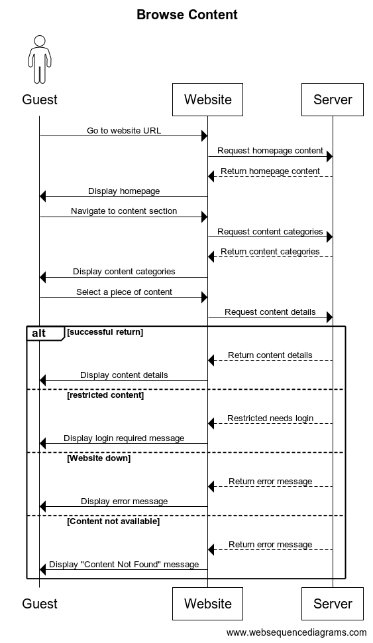

Figure : Sequence Diagram for Browse Content

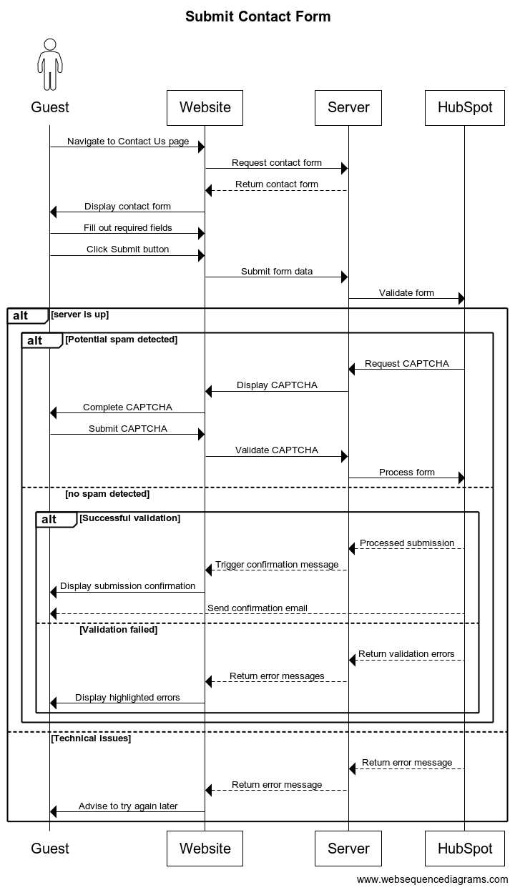

Figure : Sequence Diagram for Submit Contact Form

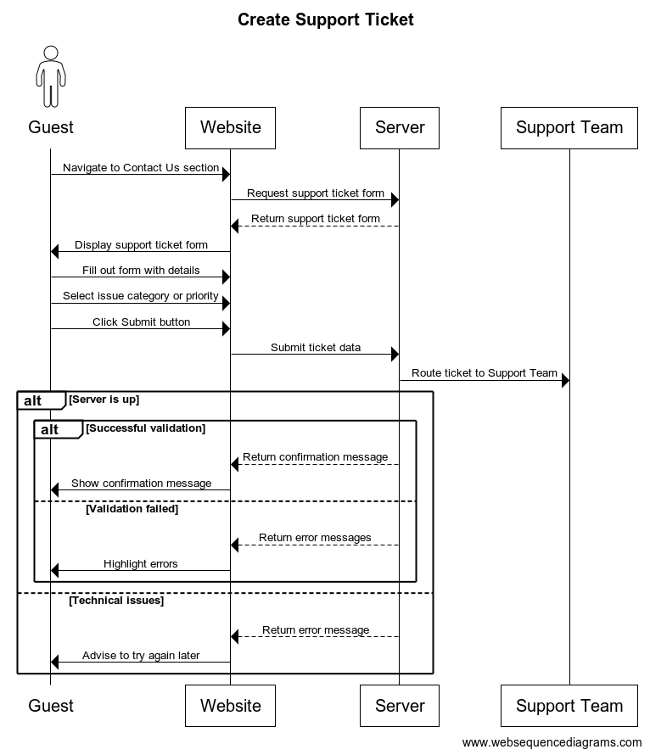

Figure : Sequence Diagram for Create Support Ticket

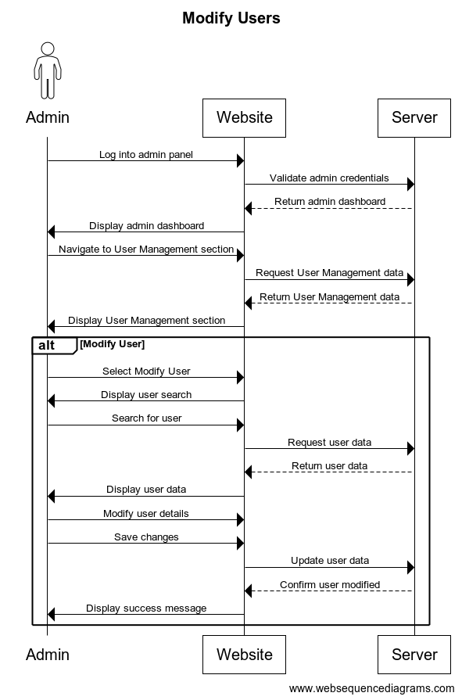

Figure : Sequence Diagram for Modify Users

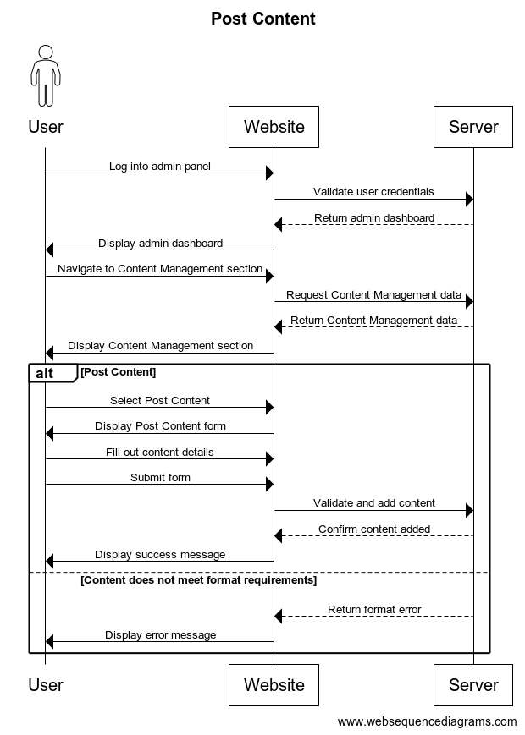

Figure : Sequence Diagram for Post Content

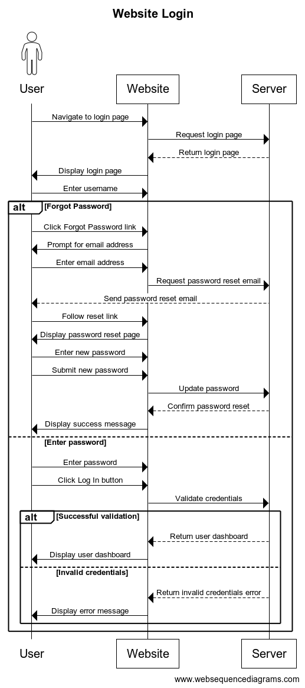

Figure : Sequence Diagram for Website Login

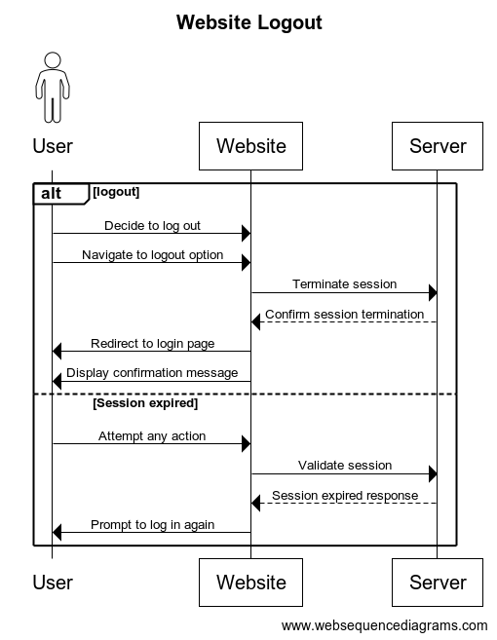

Figure : Sequence Diagram for Website Logout

## Draft of System Architecture

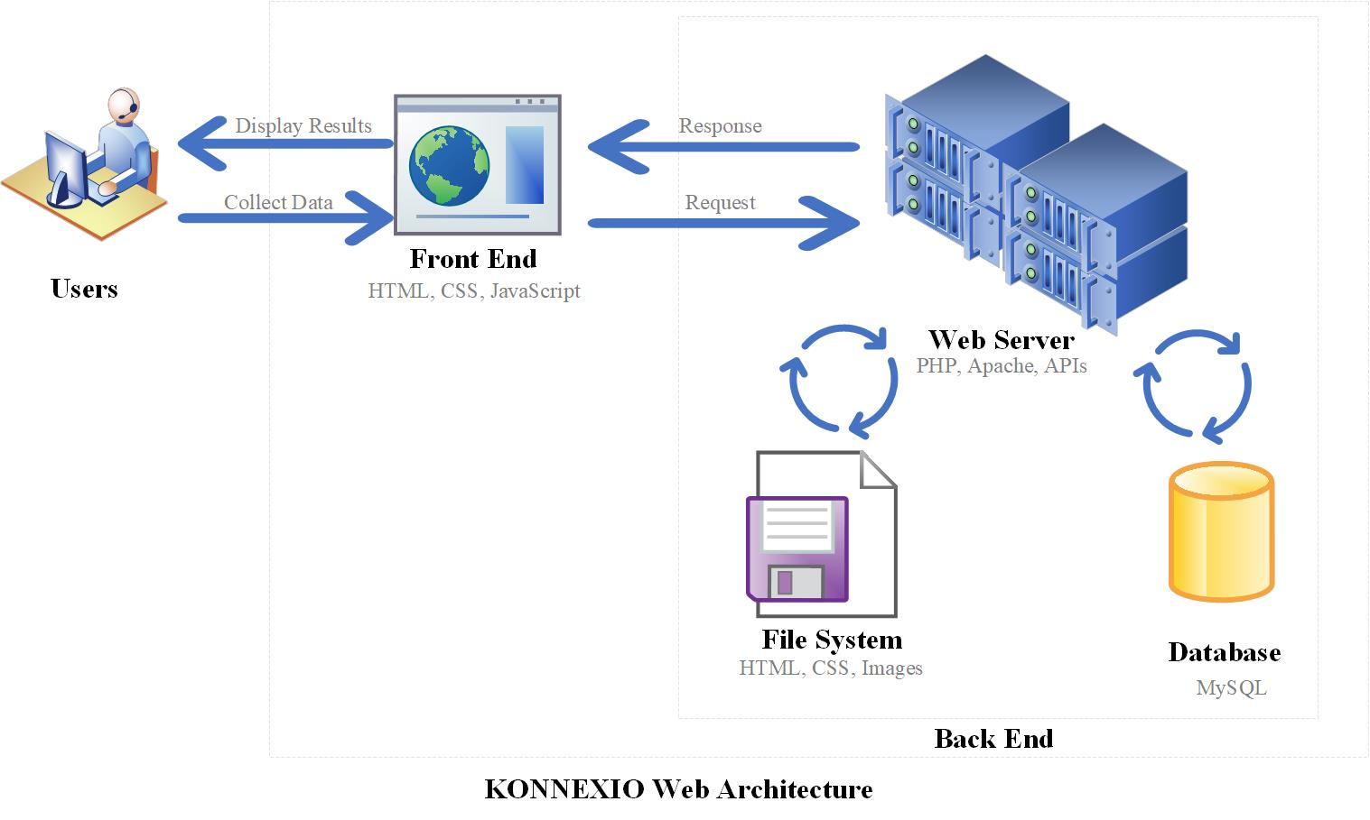

Figure : System Architecture

The diagram provides an overview of the new website’s system architecture. This includes the roles and interactions of users, the front end, the web server, the file system, and the database.

* **Users:** The end-users interact with the system through a web browser or other client application.They collect data (input) and receive/display results (output).
* **Front End:** This is the client side of the web application, built with HTML, CSS, and JavaScript. The front end gathers user input and sends it to the web server. Also, it receives data from the server and presents it to the user.
* **Web Server:** The server side that handles the logic, processing requests, and serving responses. It uses PHP, JavaScript, and APIs. These technologies will be running in a Linux operating system.
* **Request Handling**: Processes incoming requests from the front end.
* **Response Generation**: Generates appropriate responses to send back to the front end.
* **File System and Database Interaction**: Interacts with the file system and database to retrieve and store data.
* **File System:** A storage system for static content like HTML files, CSS files, and images.It stores and serves static files required by the front end.
* **Database:** A MySQL database that stores dynamic data used by the web application. It **s**tores structured data that can be queried and manipulated by the web server.

## Draft of Entity-Relationship Diagram

The ER diagram represents the structure of the new website’s database. It depicts how the elements are linked to user accounts, highlighting the relationships between these entities and how they interact within the system.

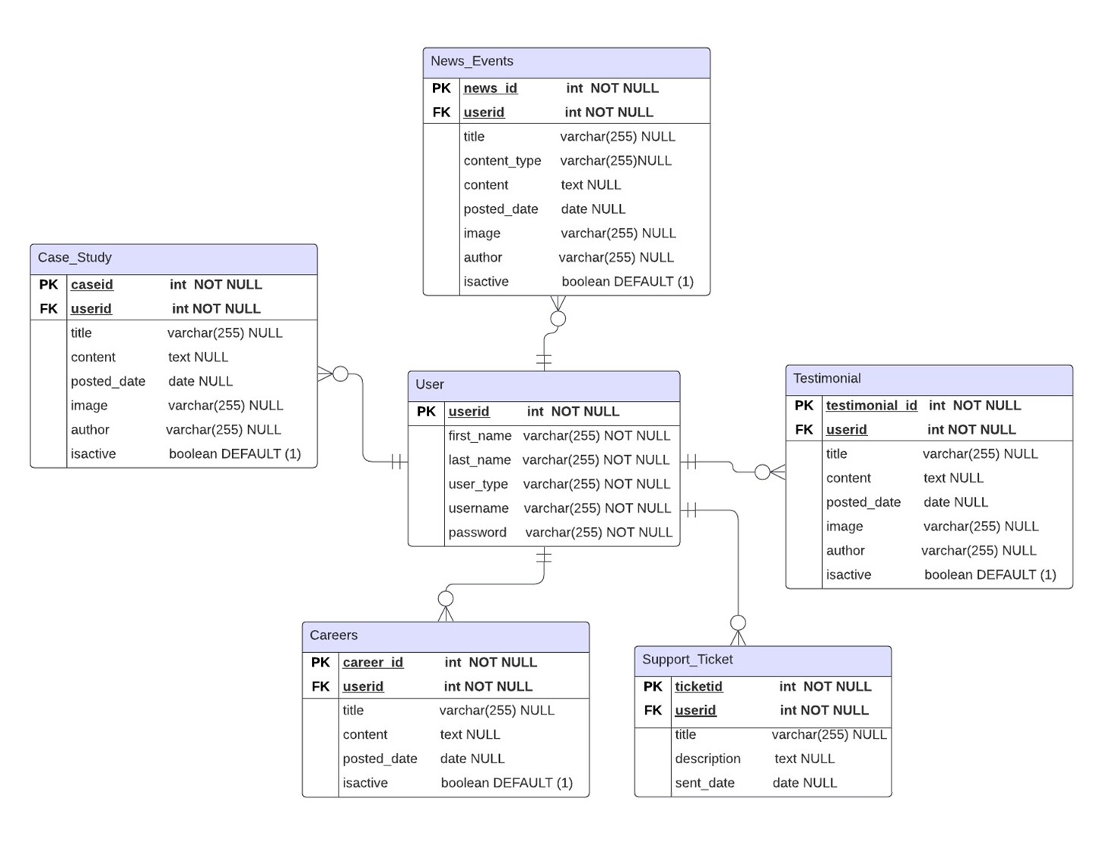

Figure : Entity-Relationship Diagram

After we collect data from the admin dashboard, the data will be saved in our specific tables. Since we have four dynamic features (Testimonials, Careers, Case Studies, and News & Events) on the website, we have created dedicated tables for storing data for each feature. Each table includes a unique column, “IsActive,” which is a Boolean type used for managing dynamic integration. Based on the value of the “IsActive” column, we dynamically display content on our website, supporting the concept of dynamic data integration through web presence (Code Power Team, 2023).

Moreover, the Support_Ticket table is specifically designed for logging data from support form submissions, including fields such as ticketid, title, description, and sent_date. The ticketid acts as a primary key, ensuring each ticket is unique.

## Data Dictionary

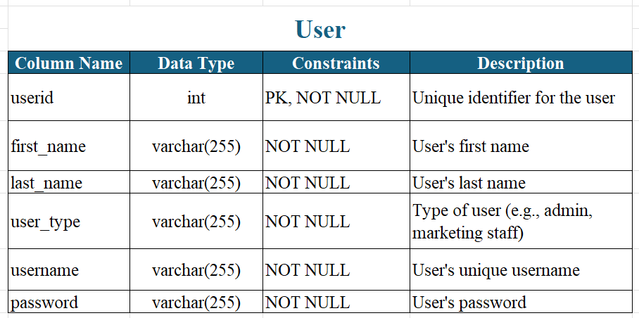

Table : Data dictionary - User table

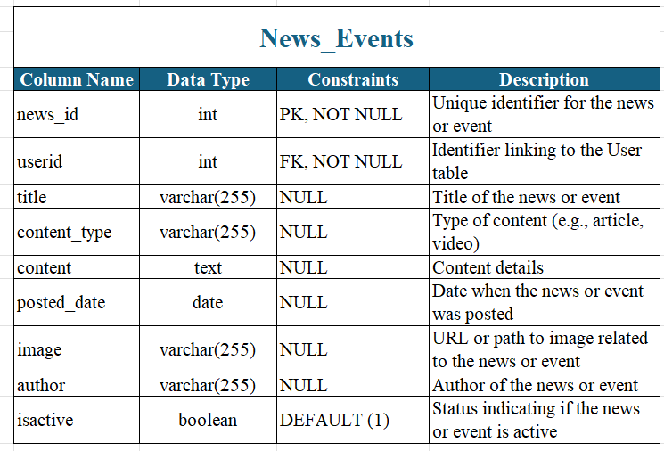

Table : Data dictionary - News_Events table

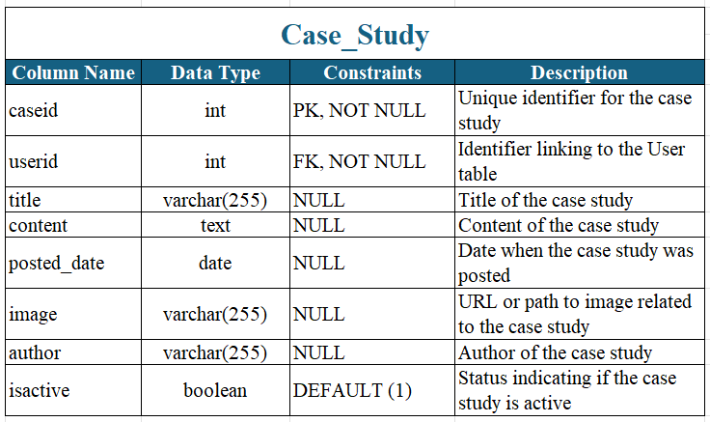

Table : Data dictionary - Case_Study table

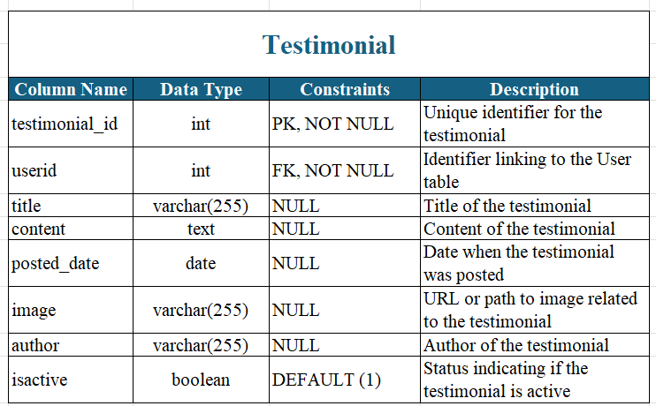

Table : Data dictionary - Testimonial table

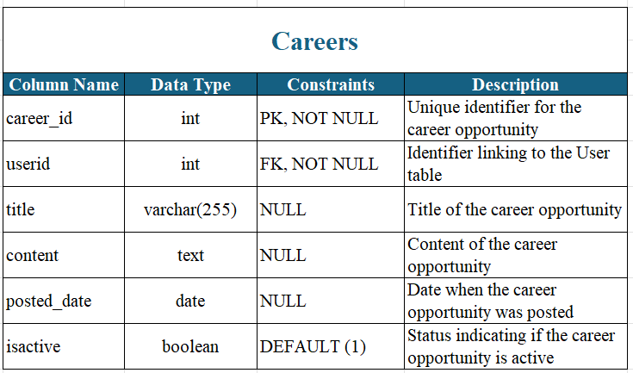

Table : Data dictionary - Careers table

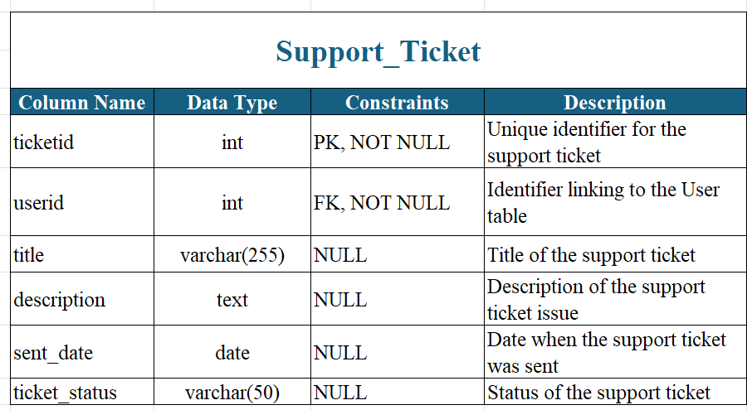

Table : Data dictionary - Support_Ticket table

## UI/UX Prototypes and Demo

### High-Fidelity wireframe of the Landing Page (Initial version)

Demo: <https://xd.adobe.com/view/52868148-6048-432e-8f28-43821ed50e93-07d5/>



Carousel with different testimonials

Static info

Turning dark when hover to show a brief description

Static transparency

Static transparency

Flip cards. On this example Hydrogen fuel cells is showing the back side.

Carousel with moving images

Figure : High-Fidelity Wireframe of Landing Page – Initial Version

### High-Fidelity wireframe of the Landing Page (Second version)

In the second iteration of the website wireframe, we incorporated the feedback we received from a graphic designer. This resulted in a more intuitive layout with improved navigation. The color scheme was refined for better readability and visual appeal, and the placement of key elements was adjusted for optimal user experience. This version represents a significant step forward in our goal to create a user-friendly, engaging website.

Demo: <https://www.figma.com/design/Vj9Bgx4WZMJAGKLhb8kvoY/capstone>



Static transparency

Flip cards

Figure : High-Fidelity Wireframe of Landing Page – Second Version

Carousel with different testimonials

Static info

Turning lighter when hover to show a brief description

Static info

Carousel with moving images

### Mid-Fidelity wireframes for Admin Portal Login Page and Admin Panel

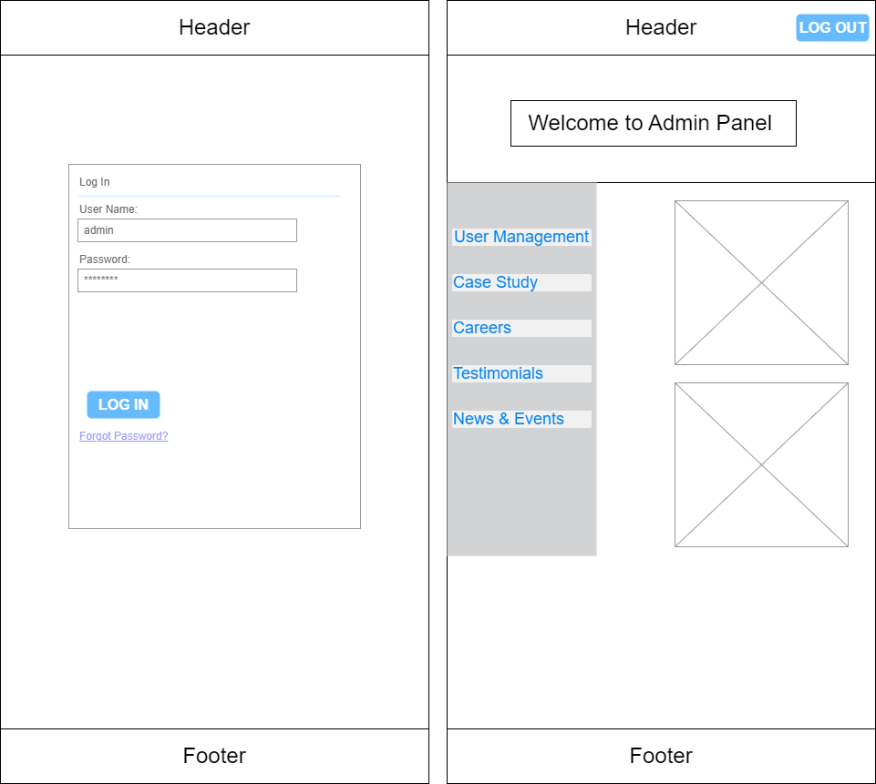

Figure : Mid-fidelity wireframes for Admin Portal Login Page and Admin Panel

### Low-Fidelity wireframes for all the pages

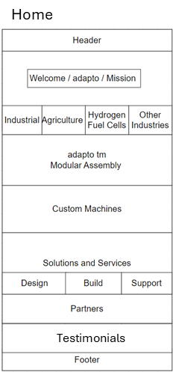

Figure : Low-fidelity wireframe for the landing page

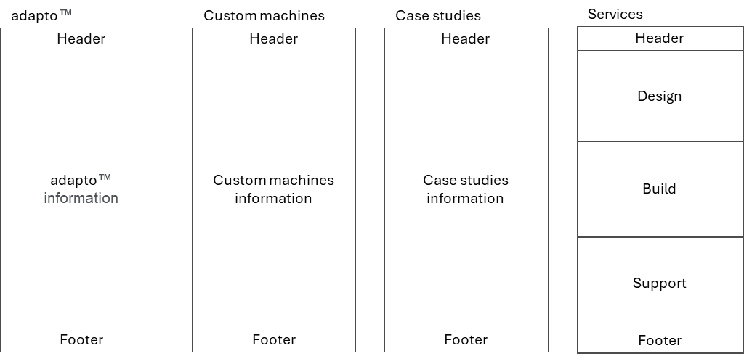

Figure : Low-fidelity wireframes for the other pages 1

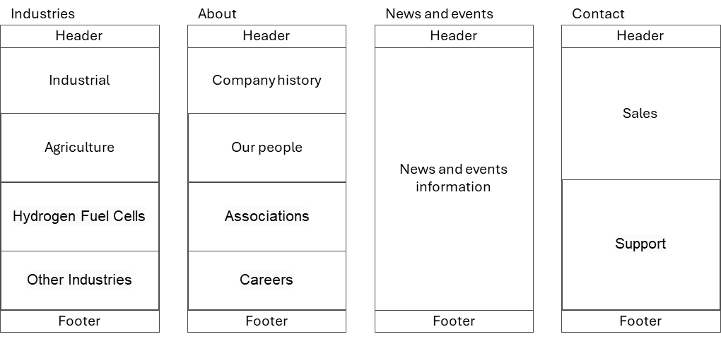

Figure : Low-fidelity wireframes for the other pages 2

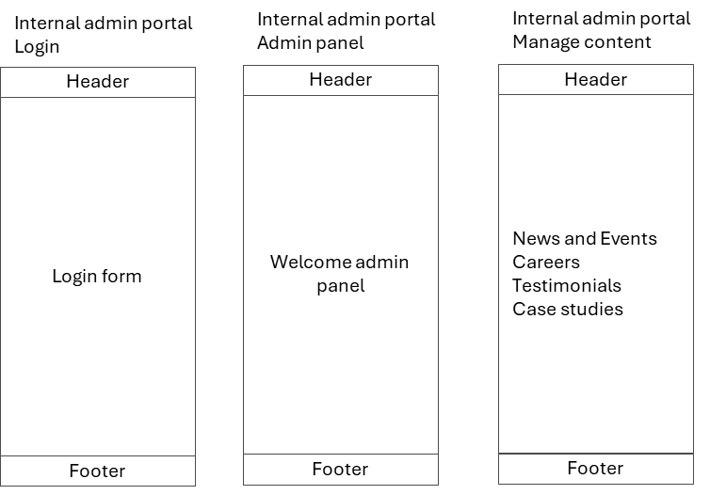

Figure : Low-fidelity wireframes for the admin portal

## References

Adobe. (n.d.). *Get-started*. Retrieved from helpx.adobe.com: https://helpx.adobe.com/xd/get-started.html

Apache. (n.d.). *Apache Module mod_proxy_balancer*. Retrieved June 21, 2024, from Apache HTTP Server Version 2.4: https://httpd.apache.org/docs/2.4/mod/mod_proxy_balancer.html

Baker Hughes. (2024). *bakerhughes.com*. Retrieved from bakerhughes.com: https://www.bakerhughes.com/

Bhosale, K. R., & Bavalekar, Y. S. (2022, June). Significance of Lamp Technology. *International Journal of Advanced Research in Science, Communication and Technology (IJARSCT), 2*(9), 41-43. doi:10.48175/IJARSCT-5191

Bootstrap. (n.d.). *introduction*. Retrieved from getbootstrap.com: https://getbootstrap.com/docs/5.0/getting-started/introduction/

Britishengines. (2024). *Britishengines.com*. Retrieved from Britishengines.com: https://www.britishengines.com/

*CI/CD with Jenkins in 3 Steps*. (2024, 6 16). Retrieved from CodeFresh: https://codefresh.io/learn/jenkins/ci-cd-with-jenkins-in-3-steps/

Code Power Team. (2023, August 25). *Static vs. Dynamic Websites in PHP: An In-depth Guide*. Retrieved June 12, 2024, from Code Power: https://www.codepwr.com/static-vs-dynamic-websites-in-php-an-in-depth-guide/

Coursera. (2024, April 1). *project-management-methodologies-your-guide*. Retrieved from coursera.org: https://www.coursera.org/articles/project-management-methodologies-your-guide

DILLON, G. (2018, 12 10). *SolarWinds*. Retrieved from Benchmarking 5 Popular Load Balancers: Nginx, HAProxy, Envoy, Traefik, and ALB: https://www.loggly.com/blog/benchmarking-5-popular-load-balancers-nginx-haproxy-envoy-traefik-and-alb/

Enginuity Inc. (2024). *enginuityinc.ca*. Retrieved from enginuityinc.ca: https://enginuityinc.ca/

Figma. (n.d.). *What-is-Figma*. Retrieved from help.figma.com: https://help.figma.com/hc/en-us/articles/14563969806359-What-is-Figma

FROONT. (2014, November 11). *9 basic principles of responsive web design*. Retrieved June 21, 2024, from FROONT: https://blog.froont.com/9-basic-principles-of-responsive-web-design/

Gergana, Boyan. (2021, Oct 5). *INTRO TO GITHUB FOR VERSION CONTROL*. Retrieved from CodingClub: https://ourcodingclub.github.io/tutorials/git/

Google. (n.d.). *About PageSpeed Insights*. Retrieved June 17, 2024, from PageSpeed Insights: https://developers.google.com/speed/docs/insights/v5/about

Google. (n.d.). *How Google Analytics works*. Retrieved June 17, 2024, from Analytics Help: https://support.google.com/analytics/answer/12159447?hl=en&ref_topic=14089939&sjid=1443854174912653845-NC

Google. (n.d.). *Search Engine Optimization (SEO) Starter Guide*. Retrieved June 17, 2024, from Google Search Central: https://support.google.com/webmasters/answer/7451184?hl=en

Google. (n.d.). *Use API Keys | Maps Embed API*. Retrieved June 12, 2024, from Google for Developers: https://developers.google.com/maps/documentation/embed/get-api-key

HubSpot. (2018, November 26). *Set up site tracking in HubSpot*. Retrieved June 17, 2024, from HubSpot: https://knowledge.hubspot.com/reports/set-up-sources-tracking?hubs_content=knowledge.hubspot.com/reports/install-the-hubspot-tracking-code&hubs_content-cta=add%20your%20do

HubSpot. (2024, March 28). *HubSpot Forms*. Retrieved June 17, 2024, from HubSpot: https://developers.hubspot.com/docs/cms/building-blocks/forms#embedding-forms-with-the-form-embed-code

HubSpot. (n.d.). *HubSpot Analytics*. Retrieved June 17, 2024, from HubSpot: https://www.hubspot.com/products/marketing/analytics

Jha, S. (2024, 05 21). *SimpliLearn*. Retrieved from AWS vs Azure: Which Cloud Platform Should You Choose in 2024?: https://www.simplilearn.com/tutorials/cloud-computing-tutorial/aws-vs-azure

XYZ Inc. (n.d.). *Xyz*. Retrieved May 23, 2024, from Xyz: https://xyz.com/

XYZ Inc. (n.d.). *XYZ Inc.* Retrieved May 23, 2024, from LinkedIn: https://www.linkedin.com/company/xyz-inc-/

Lixandre, J. (2022, 11 28). *Mindee*. Retrieved from Autoscaling compared: Azure vs GCP vs AWS: https://www.mindee.com/blog/autoscaling-comparison-aws-gcp-azure

Lucidspark. (n.d.). *UX design best practices*. Retrieved June 21, 2024, from Lucidspark: https://lucidspark.com/blog/ux-design-best-practices

MySQL. (n.d.). *MySQL 8.0 Reference Manual: 8.2 Access Control and Account Management*. Retrieved June 21, 2024, from MySQL: https://dev.mysql.com/doc/refman/8.0/en/access-control.html

News API. (n.d.). *News API*. Retrieved June 12, 2024, from News API: https://newsapi.org/

Nzube, O. E. (2022, 7 12). *How to Use Git and GitHub – Version Control Basics for Beginners*. Retrieved from Freecodecamp: https://www.freecodecamp.org/news/git-and-github-the-basics/

OptiSol Business Solutions. (n.d.). *Top 5 Advantages of creating Dynamic Website using PHP*. Retrieved June 12, 2024, from OptiSol: https://www.optisolbusiness.com/insight/top-5-advantages-of-creating-dynamic-website-using-php

Patel, N. (n.d.). *What is SEO?* Retrieved June 17, 2024, from https://neilpatel.com/what-is-seo

php. (n.d.). *PHP: ini_set*. Retrieved June 21, 2024, from PHP Manual: https://www.php.net/manual/en/function.ini-set.php

php. (n.d.). *PHP: OpenSSL*. Retrieved June 21, 2024, from PHP Manual: https://www.php.net/manual/en/book.openssl.php

php. (n.d.). *PHP: password_hash*. Retrieved June 21, 2024, from PHP Manual: https://www.php.net/manual/en/function.password-hash.php

php. (n.d.). *PHP: session_set_cookie_params*. Retrieved June 21, 2024, from PHP Manual: https://www.php.net/manual/en/function.session-set-cookie-params.php

phpMyAdmin. (n.d.). *Configuration*. Retrieved June 21, 2024, from phpMyAdmin 5.2.0 documentation: https://docs.phpmyadmin.net/en/release_5_2_0/config.html

phpMyAdmin. (n.d.). *Two-factor authentication*. Retrieved June 21, 2024, from phpMyAdmin 5.1.4 documentation: https://docs.phpmyadmin.net/en/latest/two_factor.html

Quilty, D. (2024, May 9). *Securing Your MySQL Database: Essential Best Practices*. Retrieved June 21, 2024, from PERCONA: https://www.percona.com/blog/mysql-database-security-best-practices/

Sci Engineering. (2019). *Sciengineering.com*. Retrieved from Sciengineering.com: https://sciengineering.com/

Shah, V. (2024, February 29). *PHP and MySQL: Create Dynamic Websites Easily*. Retrieved June 12, 2024, from WPWEB Infotech: https://wpwebinfotech.com/blog/php-and-mysql/

Sommerville, I. (2016). *Software Engineering.* London, UK: Pearson.

Springer, A. (2023, April 6). *What-is-Jira-Software-and-why-use-it/ba-p/2323812*. Retrieved from community.atlassian.com: https://community.atlassian.com/t5/Jira-articles/What-is-Jira-Software-and-why-use-it/ba-p/2323812

Sutherland, K. S. (2020, November 1). *2020-Scrum-Guide-US.pdf.* Retrieved from scrumguides.org: https://scrumguides.org/docs/scrumguide/v2020/2020-Scrum-Guide-US.pdf#zoom=100

Tilley, S. (2020). *Systems Analysis and Design.* Boston, USA: Cengage Learning.

Tovarys, J. (2024, 1 11). *Better Stack*. Retrieved from Datadog vs. New Relic: a side-by-side comparison for 2024: https://betterstack.com/community/comparisons/datadog-vs-newrelic/

## Appendix

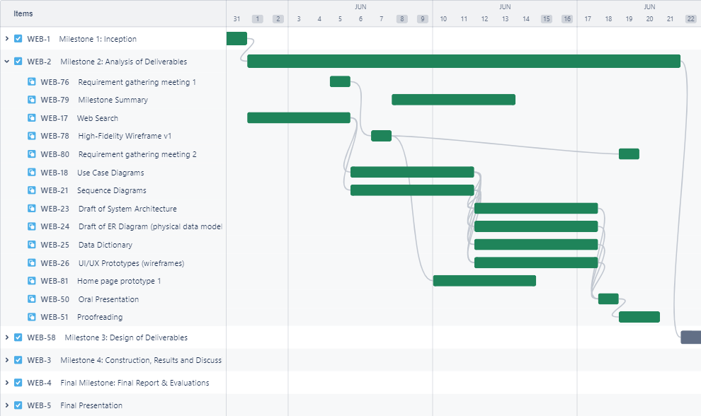

Figure 18: Gantt Chart Weekly View Milestone 2

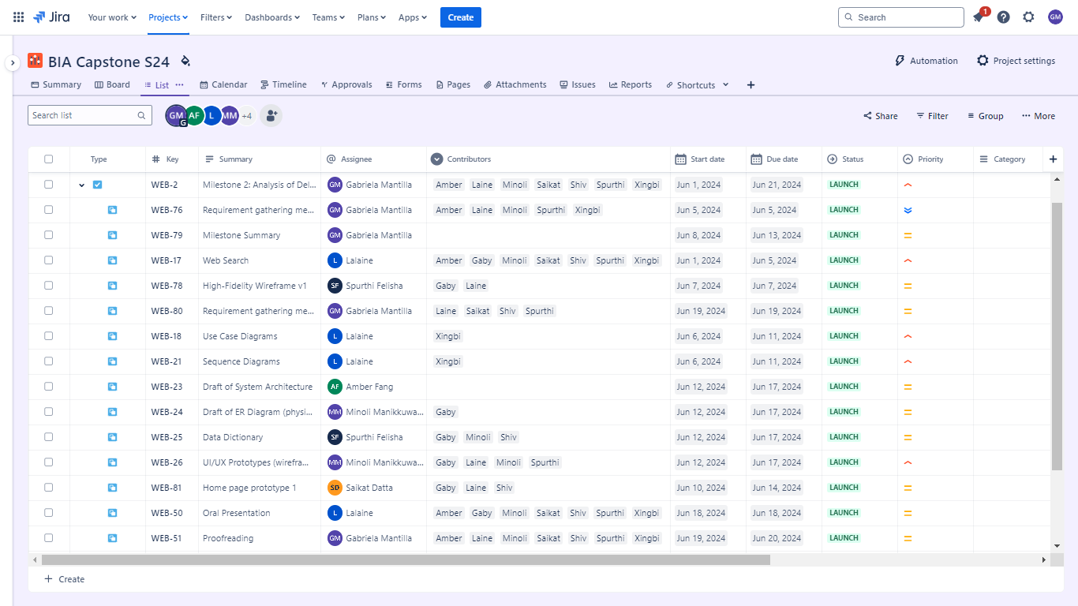

Figure 19: Milestone 2 Details